Craig ELlrod

senior cloud security architect

Checking Armor Agent Status with N-Able

N-Central

Table of Contents

Introduction 3

Prerequisites 3

How it works 3

Create Automation Manager .amp File 4

Step 1 – Log Into N-Central and start the Automation Manager 4

Step 2 – Select New Policy 5

Step 3 – Name the automation policy 5

Step 4 – Search for PowerShell Script 6

Step 5 – Select the Output Parameters tab and Add an output parameter 7

Step 6 – Select the Script Tab and Edit 8

Step 7 – Paste the Armor Installation Script into the “Script” window 9

Step 8 – Run the policy to test it 10

Step 9 – Save the policy 11

Step 10 – Upload the policy to the central repository 12

Create Scheduled Task in N-Central 13

Step 11 – Navigate back to the N-Able N-Central Web Browser Interface 13

Step 12 – Navigate to Administration 🡪 Service Management 🡪 Custom Services. 13

Step 13 – Add Automation Service Name 14

Step 14 – Set the Schedule 15

Step 15 – Set the Thresholds 15

Step 16 – Enable the status check policy 16

Step 17 – Select Add 17

Step 18 – Select 1 instance of the Armor Agent – Check Armor Core Status service 17

Step 19 – Navigate to Views 🡪 Add Devices 🡪 <machine name> 🡪 Monitoring 18

Step 20 – Status should turn green 18

Step 21 – Click on the ‘Armor Agent – Check Armor Core Status’ policy 19

Step 22 – Select the ‘Self-Healing’ tab 19

Step 23 – Select the ‘Action’ tab 19

Test the Self-Healing Policy 20

Step 24 – Navigate to Views 🡪 All Devices 🡪 <machine name> 🡪 Monitoring tab 20

Step 25 – Go into Windows 🡪 Computer Management 🡪 Services 21

Step 26 – In N-Central, from the customer view, Navigate to Reports 🡪 Events 21

Step 27 – View Report 22

# Introduction

This ARMOR Defense field guide will present a step-by-step method to deploy the Armor Agent automatically using the automation tools within N-Able’s N-Central platform.

## Prerequisites

An account with N-Able N-Central access.

<https://n-able.com>

An Armor Management Portal account – Managed Service Provider

<https://amp.armor.com>

The github for this tutorial.

<https://github.com/surfd4wg/armor_NAble>

The scripts for this tutorial.

CheckArmorStatus.ps1

ARMORstatus.amp

Note: The N-Able automation scripts and platform do not work with MAC OSX.

Additionally, There is a distinction with N-Able where they refer to the Managed Service Provider (MSP) account as the Service Organization (SO). Some illustrations in this document will refer to the “SO” or “MSP”, while other illustrations will refer to the MSP’s or SO’s customer, as “Customer”.

## How it works

Monitoring the Armor Agent Status for Windows through N-Able N-Central, involves these simple steps.

* Create an automation policy .amp file in N-Able Automation Manager – to check Armor status
* Create a schedule task in N-Central to check the Armor Agent status
* Create a self-healing policy to automatically re-start the Armor Core agent if it Failed

# Create Automation Manager .amp File

### Step 1 – Log Into N-Central and start the Automation Manager

Navigate to the SO level (Top Level) of N-Central, and launch the Automation Manager.

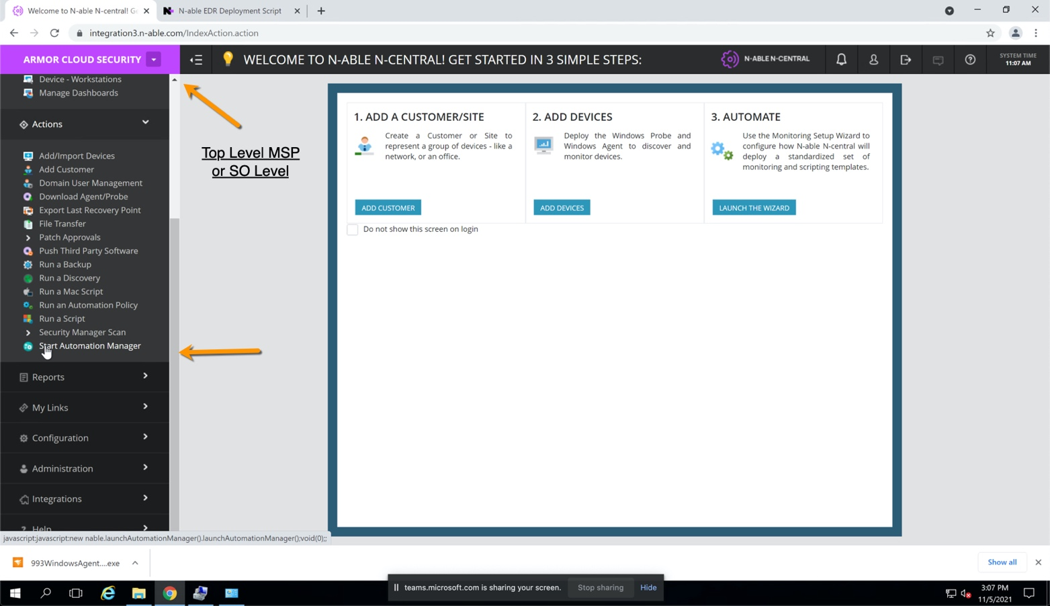

﻿

### Step 2 – Select New Policy

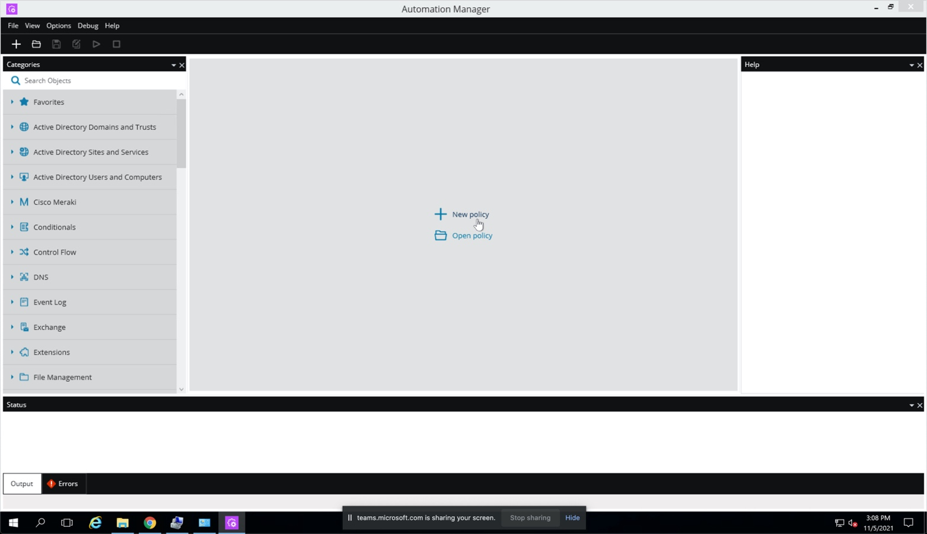

### Step 3 – Name the automation policy

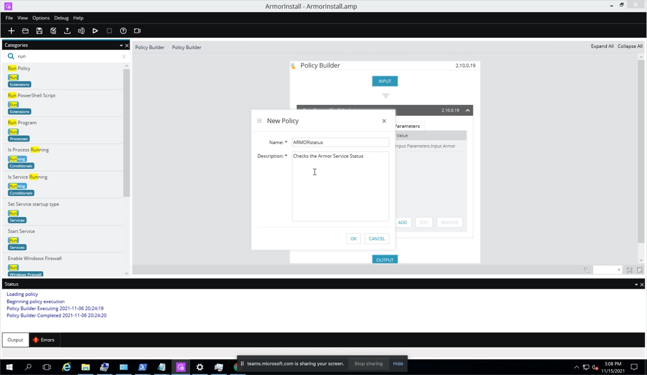

Create the automation policy with the following fields

Name: ARMORstatus

Description: Checks the Armor Service Status

### Step 4 – Search for PowerShell Script

In the left navigation search for “Run PowerShell”, then drag that script to the middle bar between Input and Output.

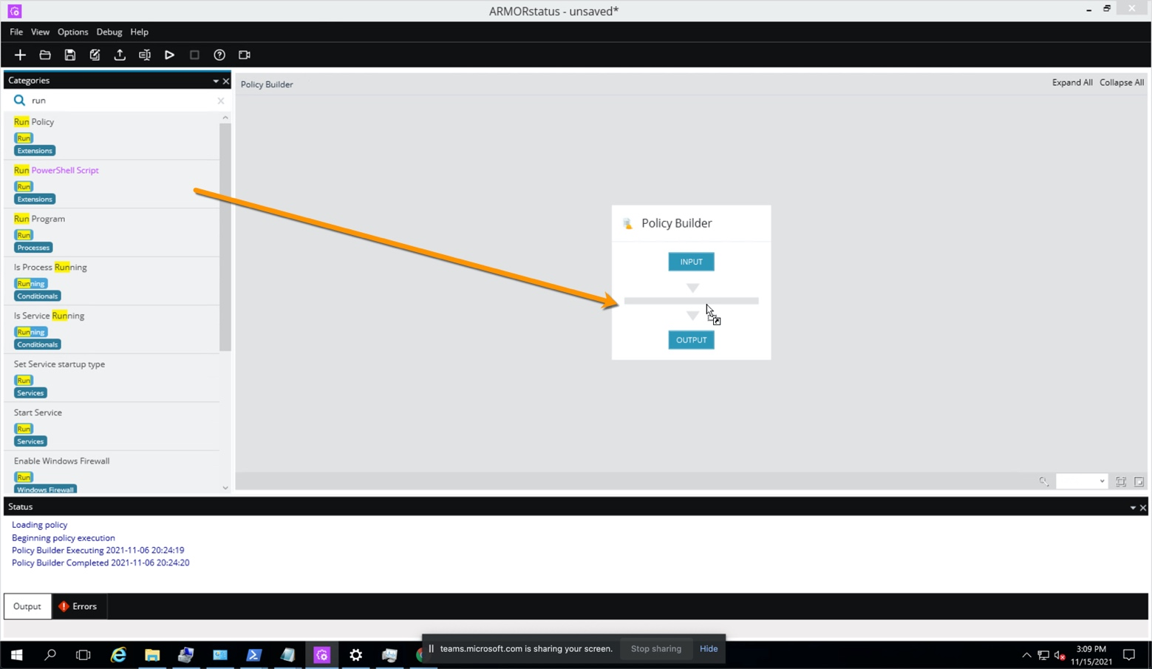

### Step 5 – Select the Output Parameters tab and Add an output parameter

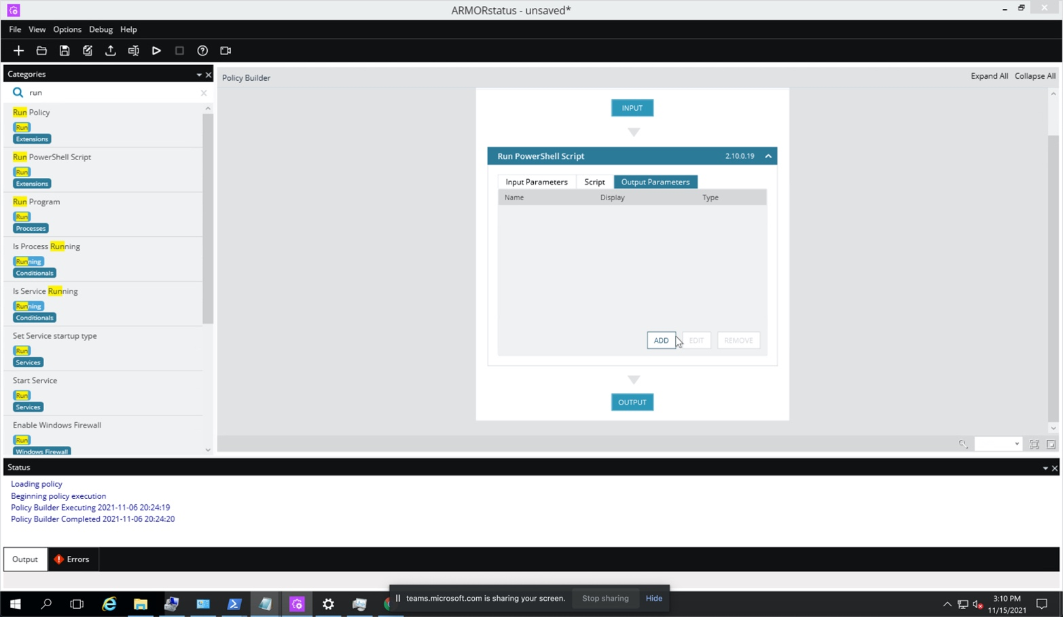

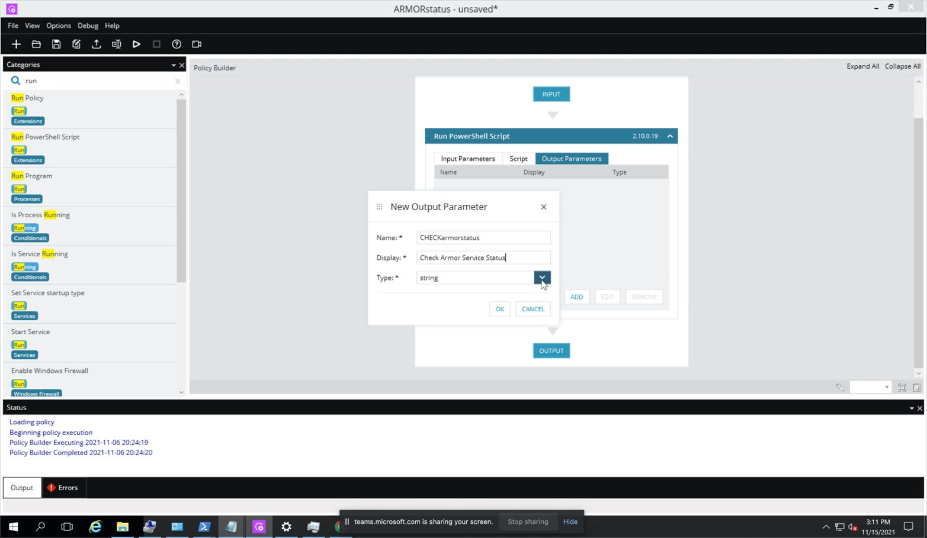

Create the output parameter with the following fields

Name: CHECKarmorstatus

Display: Check Armor Service Status

Type: String

### Step 6 – Select the Script Tab and Edit

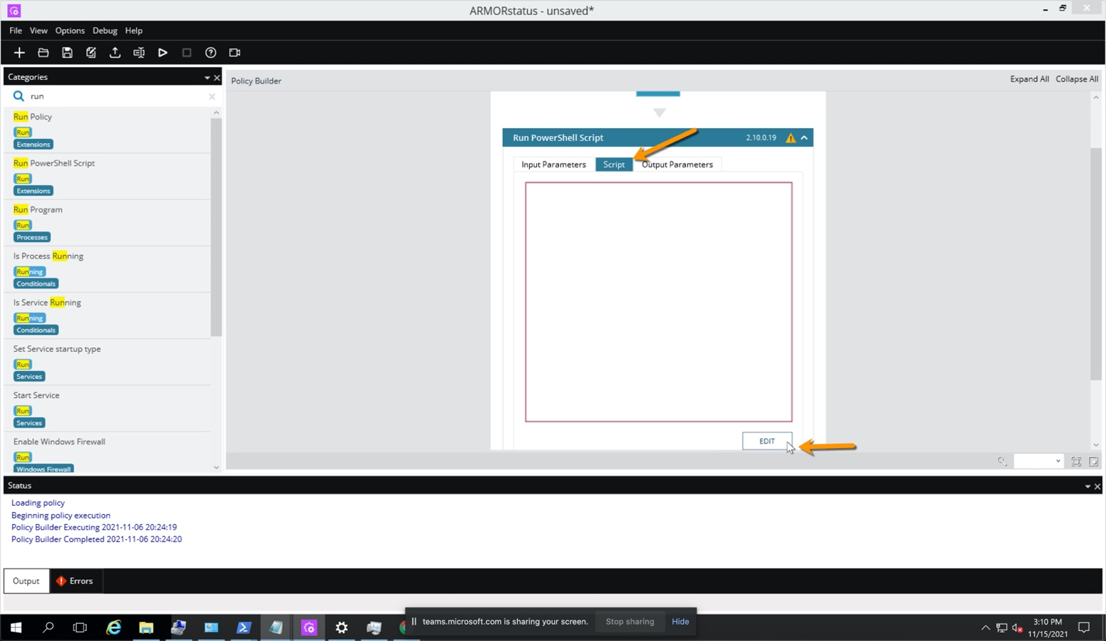

### Step 7 – Paste the Armor Installation Script into the “Script” window

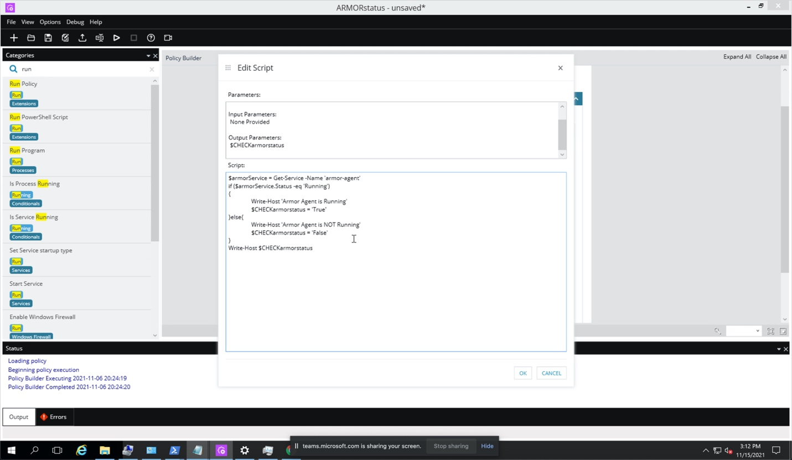

Note: Use the following PowerShell script, which can also be found on the GitHub site.

$armorService = Get-Service -Name 'armor-agent'

if ($armorService.Status -eq 'Running')

{

Write-Host 'Armor Agent is Running'

$CHECKarmorstatus = 'True'

}else{

Write-Host 'Armor Agent is NOT Running'

$CHECKarmorstatus = 'False'

}

Write-Host $CHECKarmorstatus

Click on ‘Ok’, then ‘Ok’.

### Step 8 – Run the policy to test it

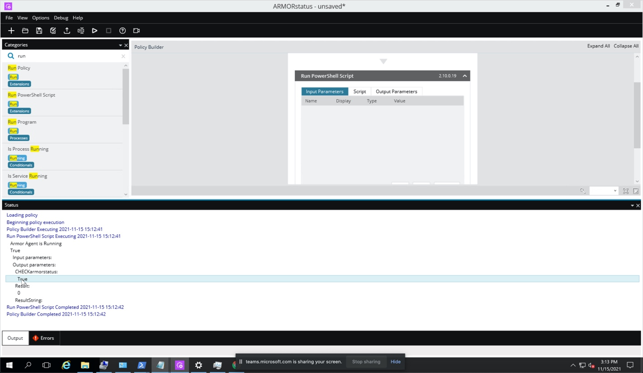

Note: The Armor Agent must be installed on the same machine to test the policy.

### Step 9 – Save the policy

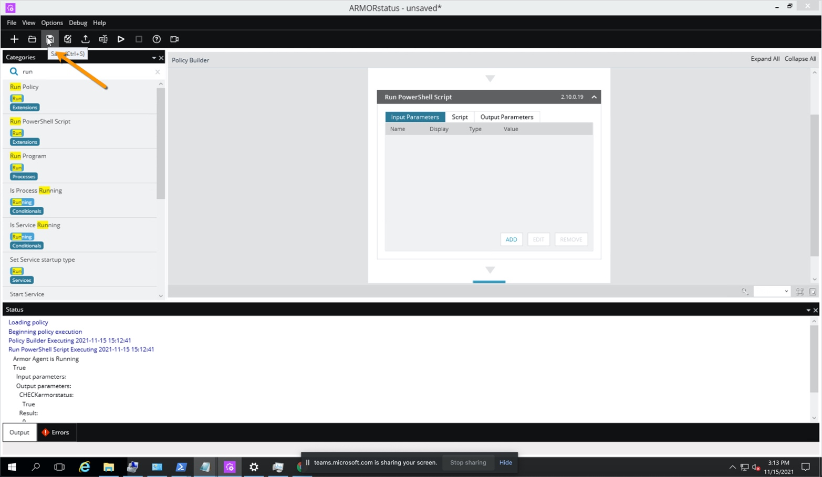

### Step 10 – Upload the policy to the central repository

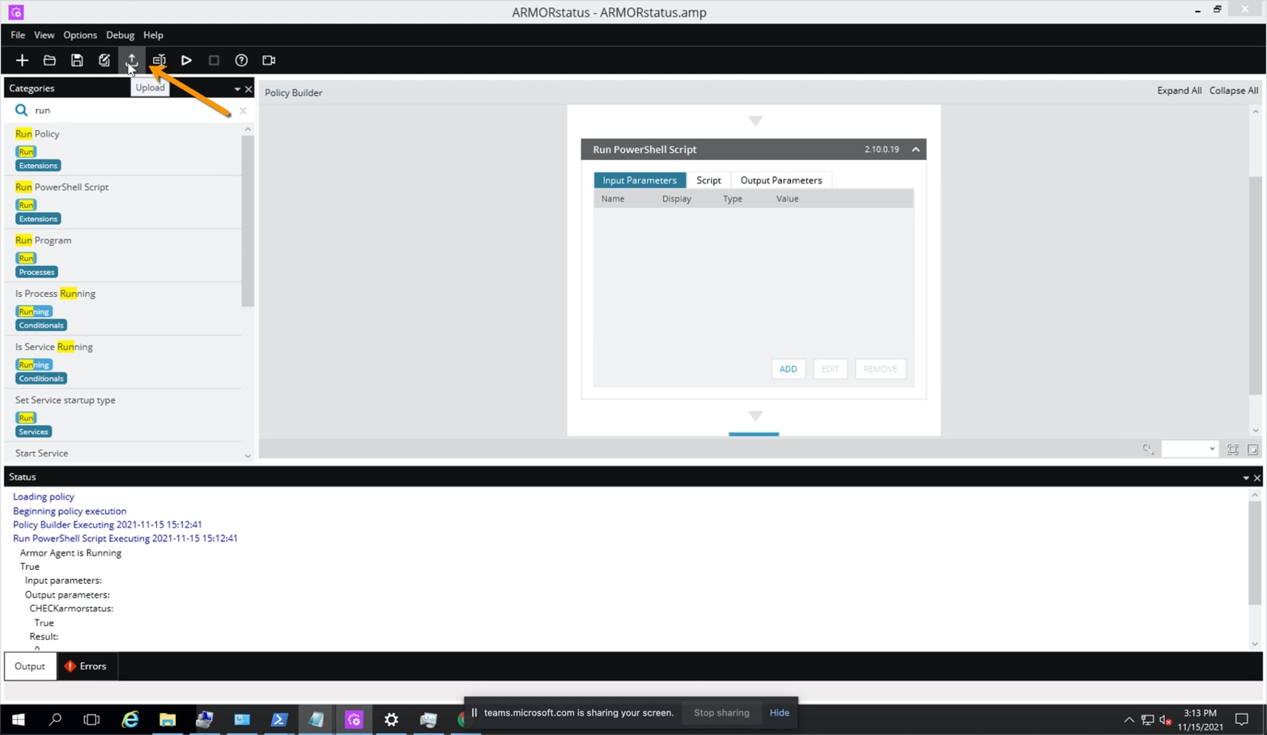

# Create Scheduled Task in N-Central

### Step 11 – Navigate back to the N-Able N-Central Web Browser Interface

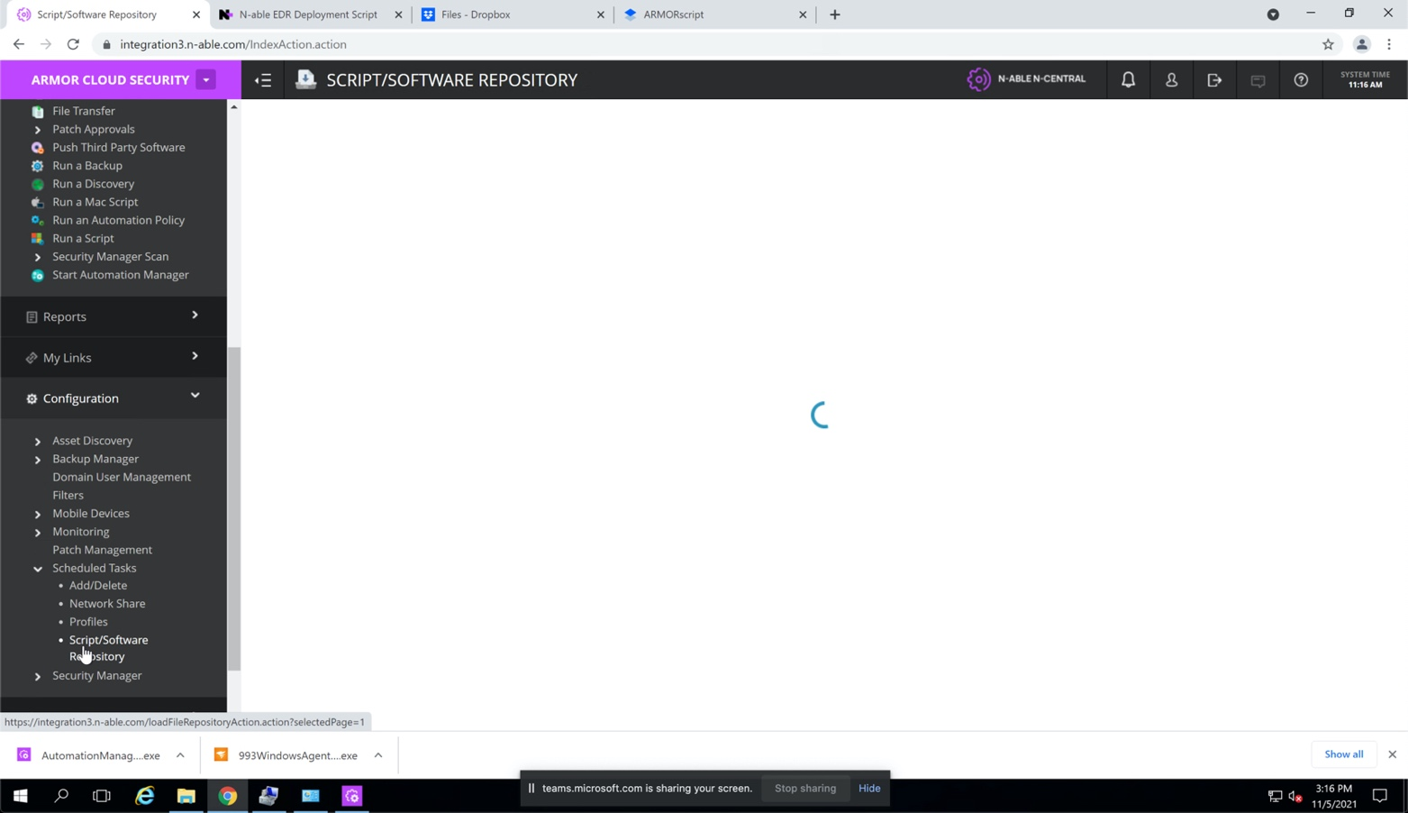

### Step 12 – Navigate to Administration 🡪 Service Management 🡪 Custom Services.

Select Add 🡪 Service 🡪 Automation Manager Policy

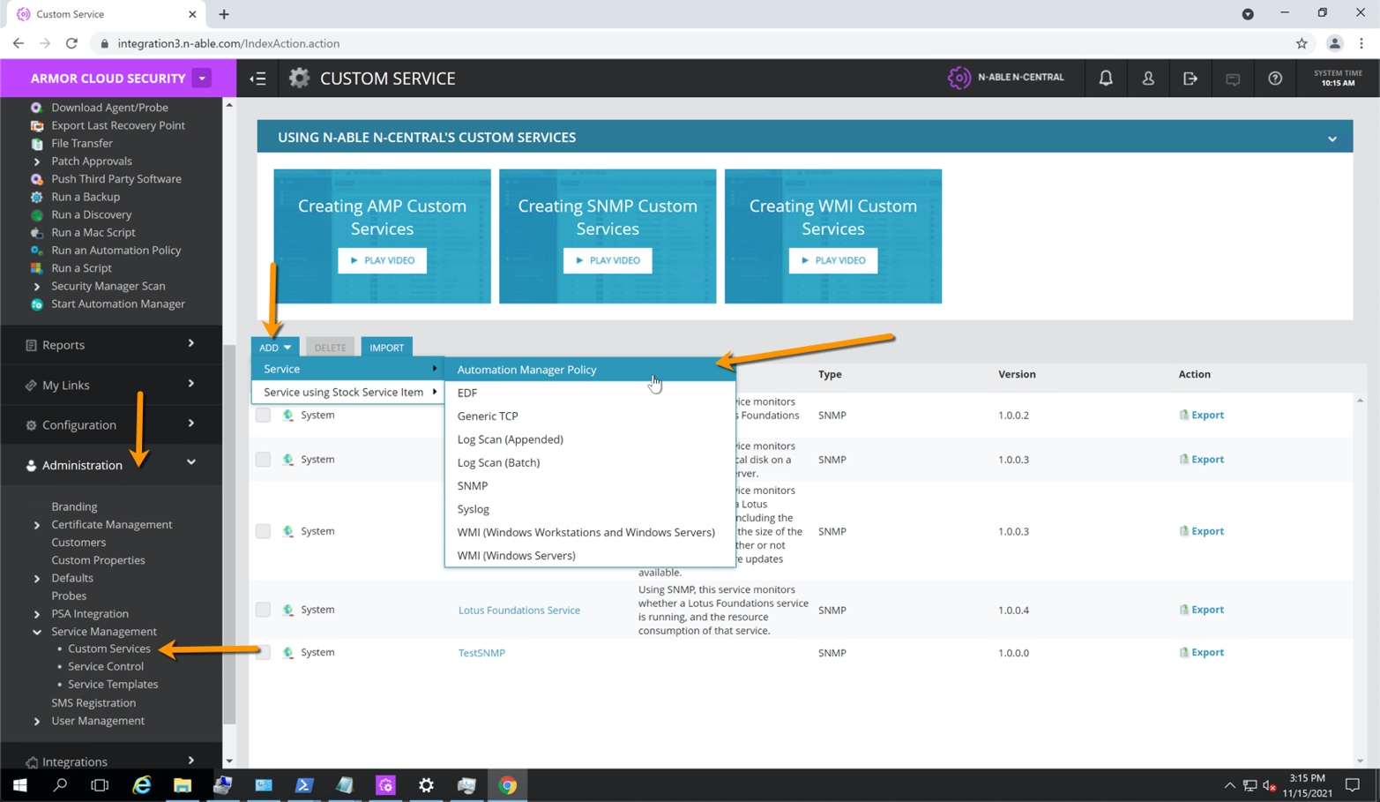

### Step 13 – Add Automation Service Name

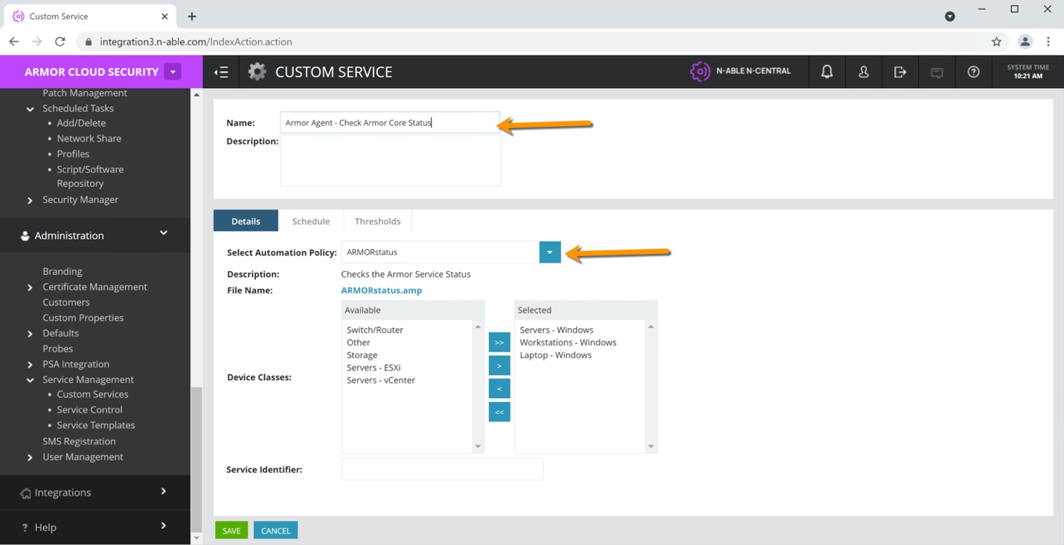

Name the service ‘Armor Agent – Check Armor Core Status’. The Automation Policy should be set to the policy we created in the Automation Manager earlier – ‘ARMORstatus.amp’.

### Step 14 – Set the Schedule

Configure the interval you want to check the agent status.

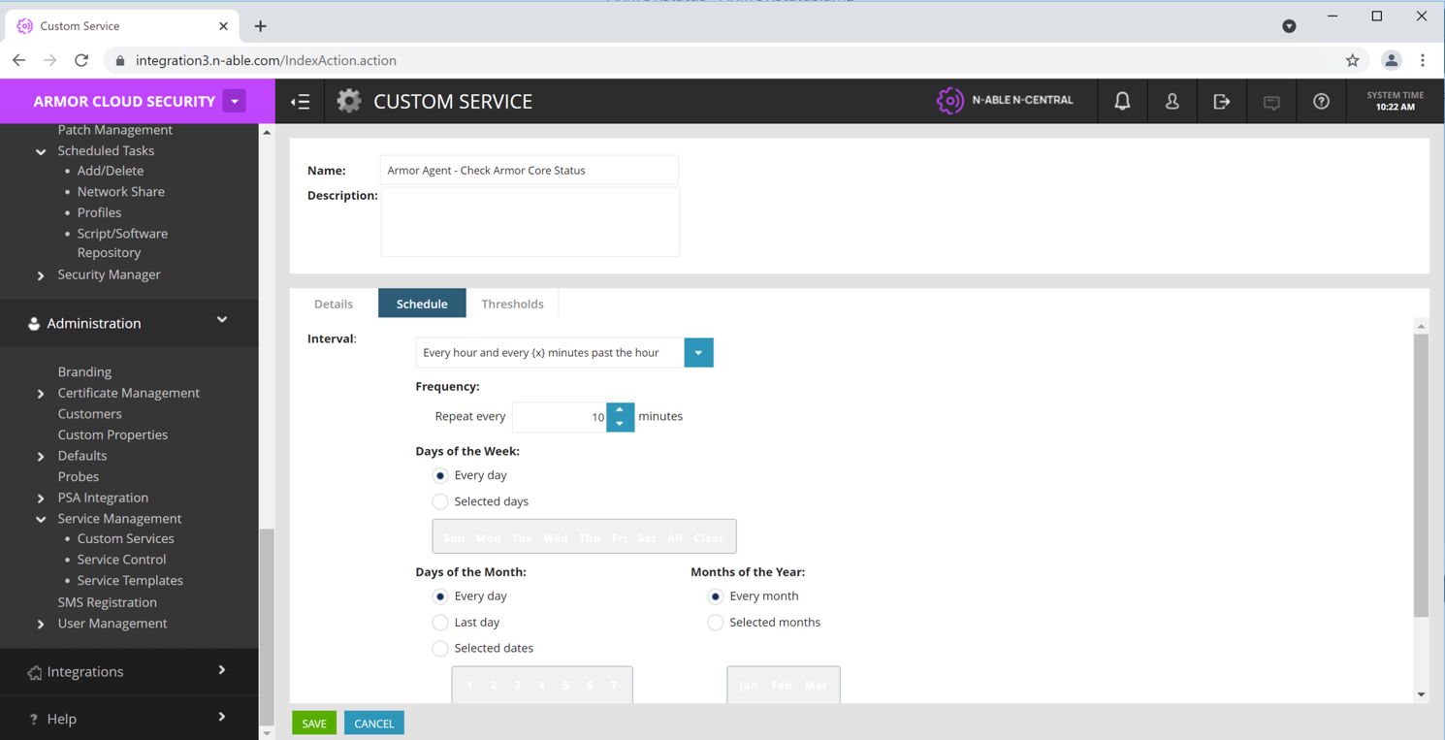

### Step 15 – Set the Thresholds

Configure the Threshold to trigger the automation policy. If the value of the string isn’t set to True after the automation status run’s, the set the state to Failed.

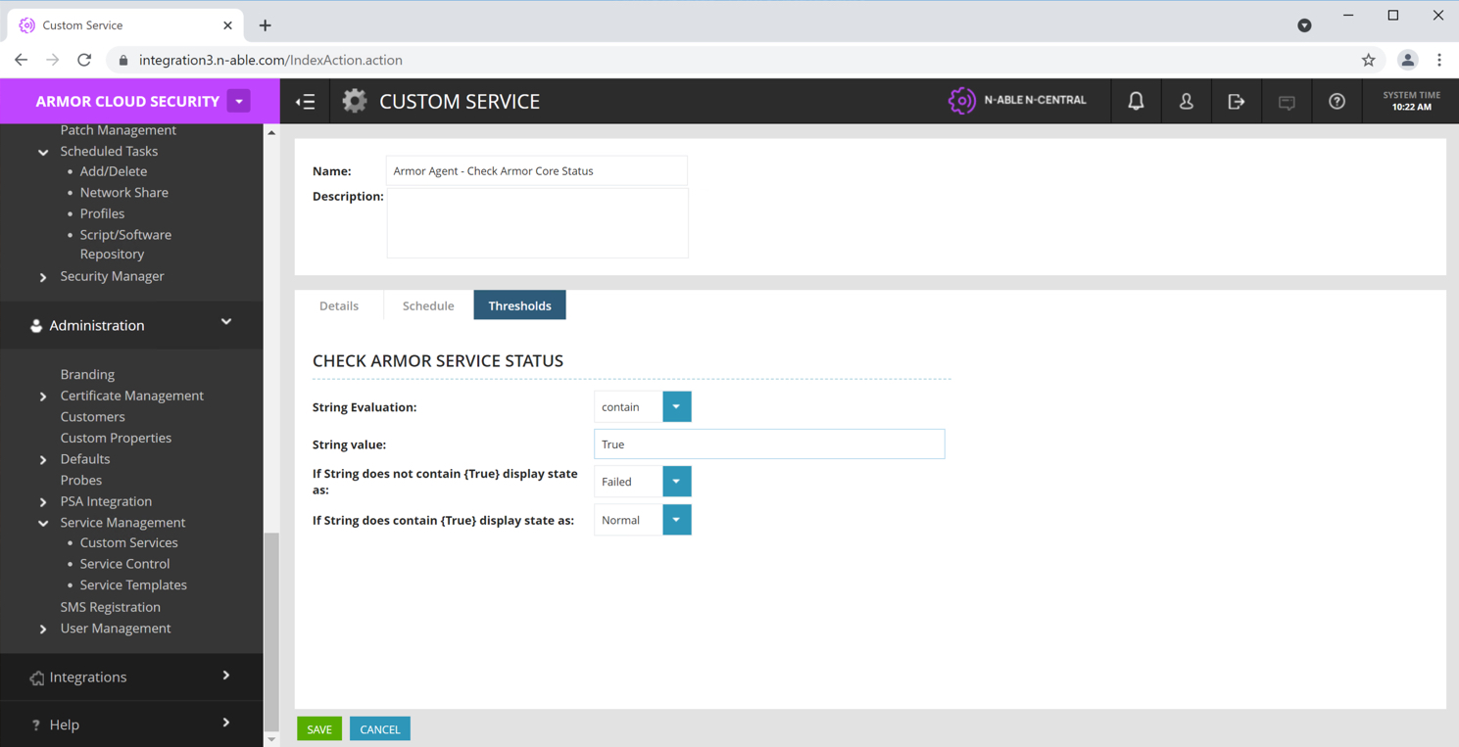

### Step 16 – Enable the status check policy

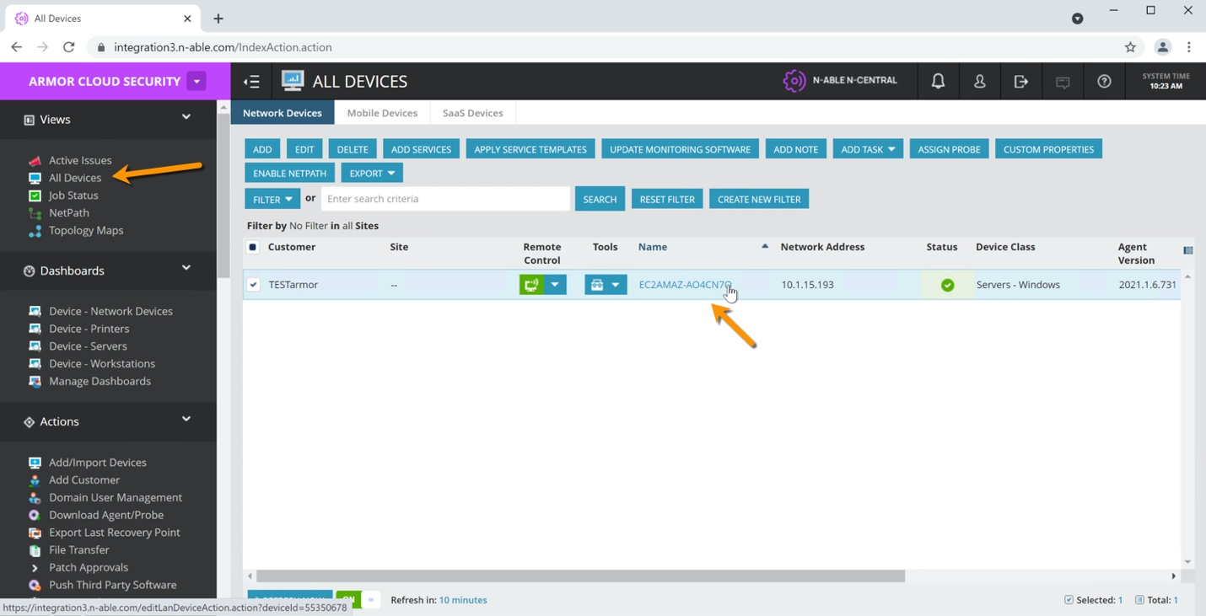

From the SO or MSP level, select Views 🡪 All Devices. Click on the machine name.

### Step 17 – Select Add

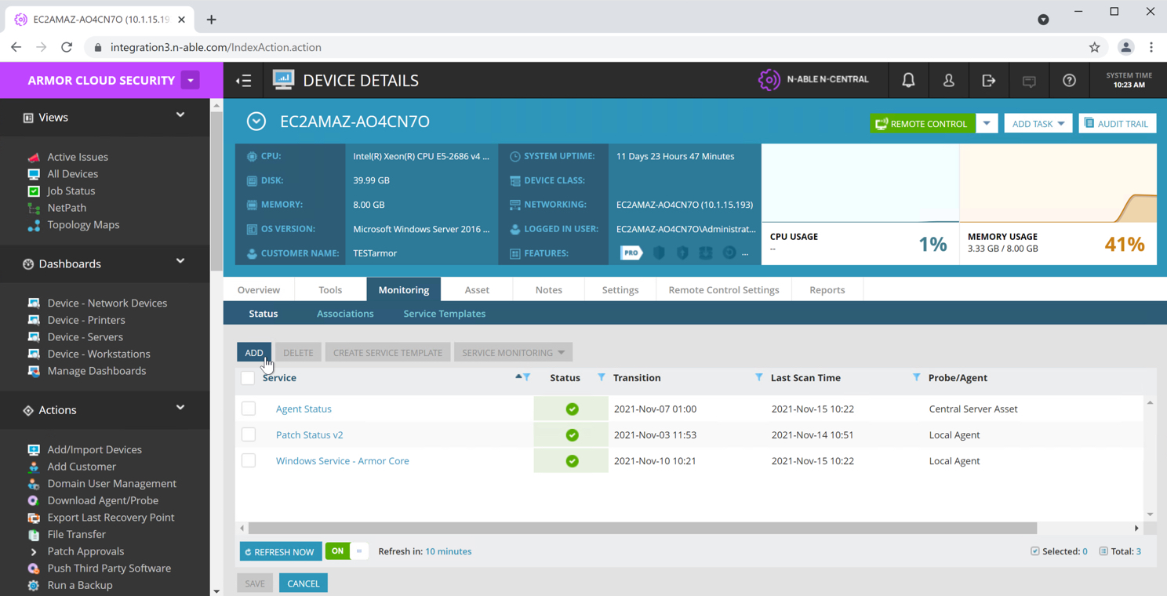

### Step 18 – Select 1 instance of the Armor Agent – Check Armor Core Status service

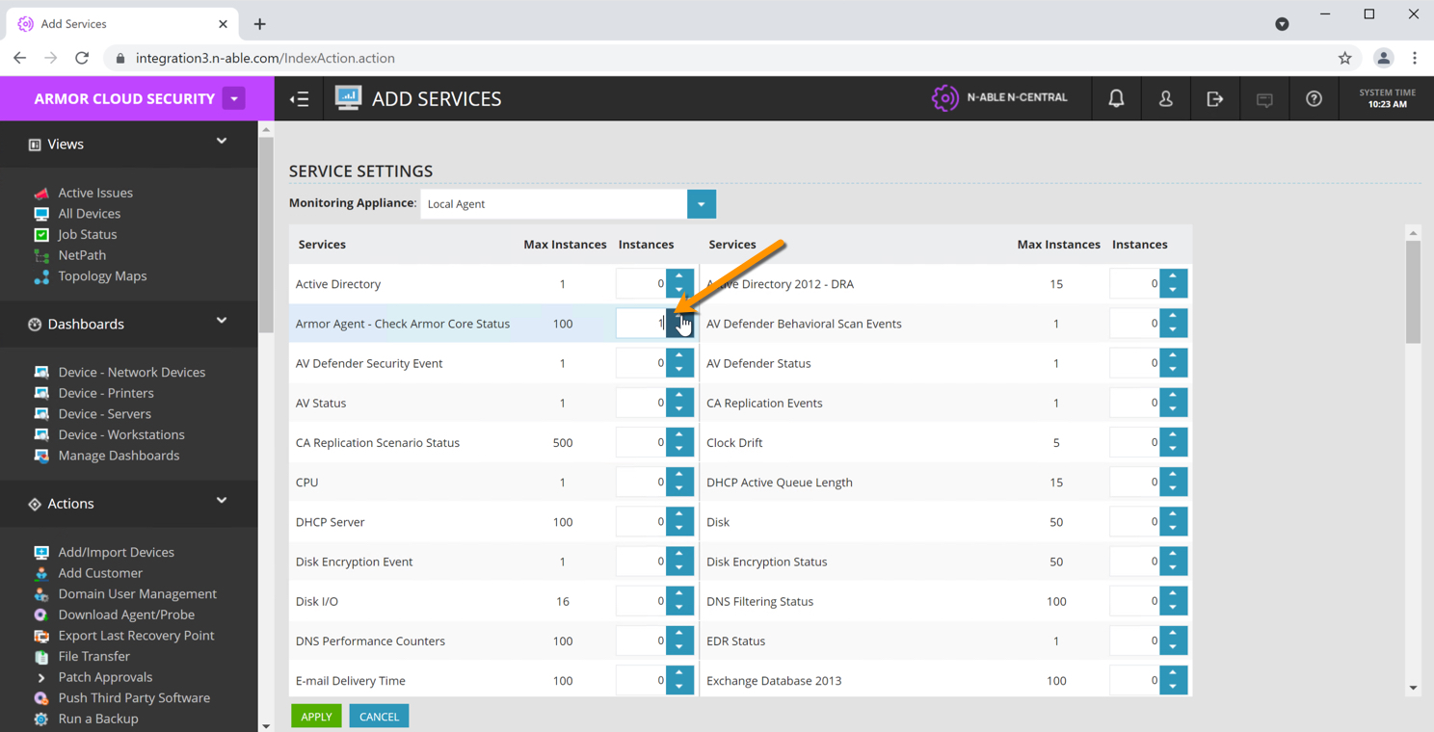

### Step 19 – Navigate to Views 🡪 Add Devices 🡪 <machine name> 🡪 Monitoring

Select the Service Monitoring drop down, and ‘Scan Now’.

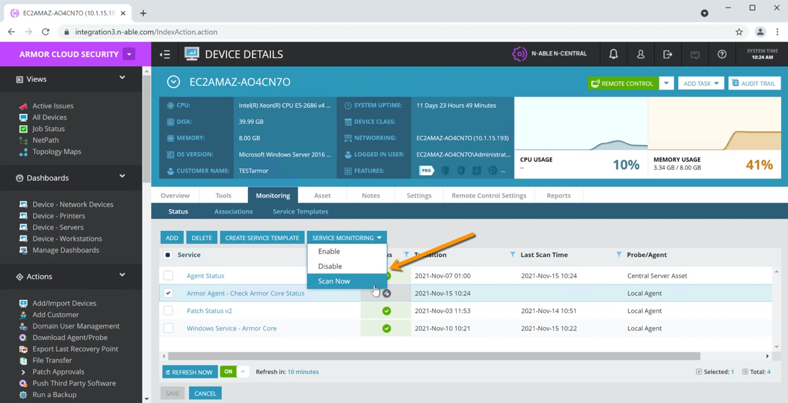

### Step 20 – Status should turn green

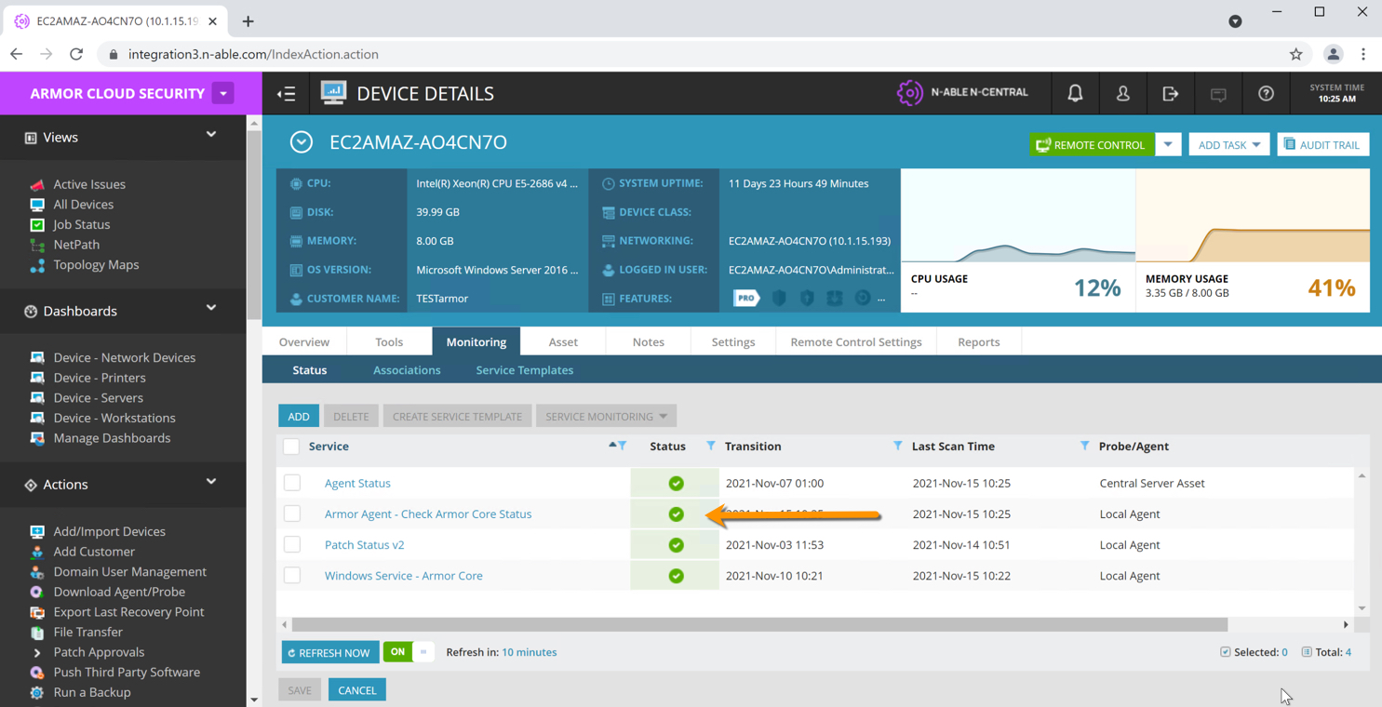

### Step 21 – Click on the ‘Armor Agent – Check Armor Core Status’ policy

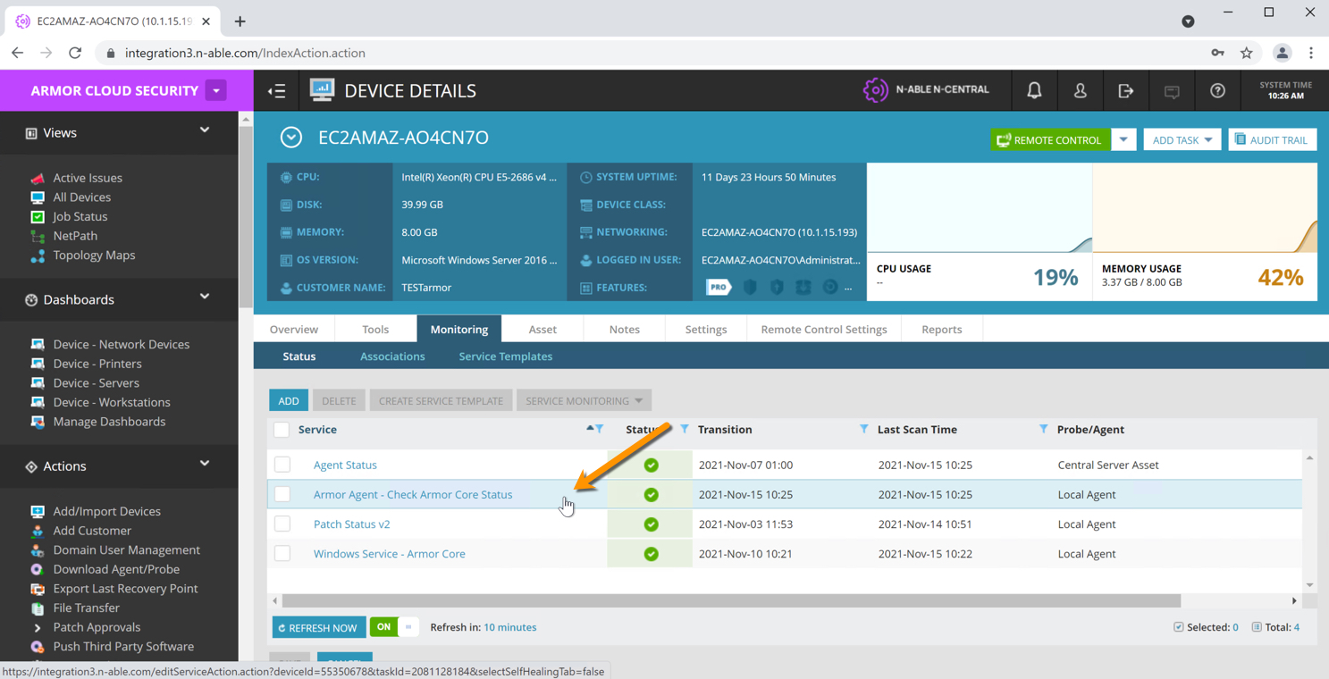

### Step 22 – Select the ‘Self-Healing’ tab

Set the trigger to ‘Failed’

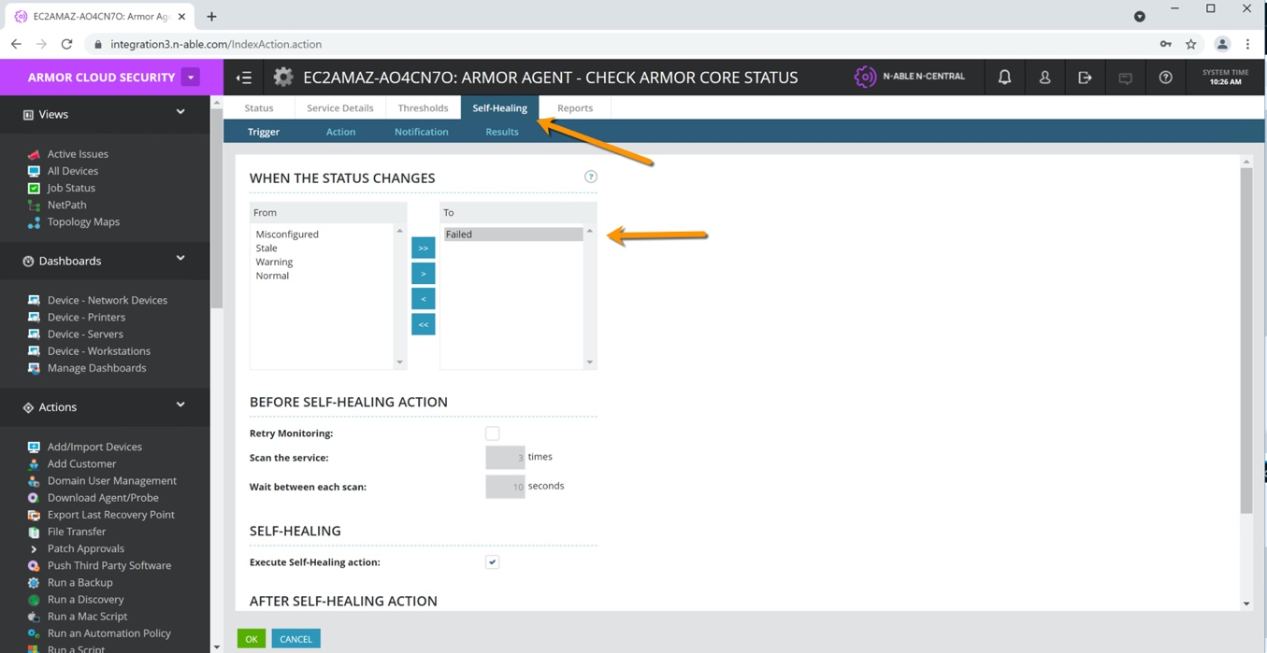

### Step 23 – Select the ‘Action’ tab

Set the number of times to check the status and perform a self-healing action. Select the ‘Armor Core’ service as the service to be restarted automatically if status is detected as ‘Failed’.

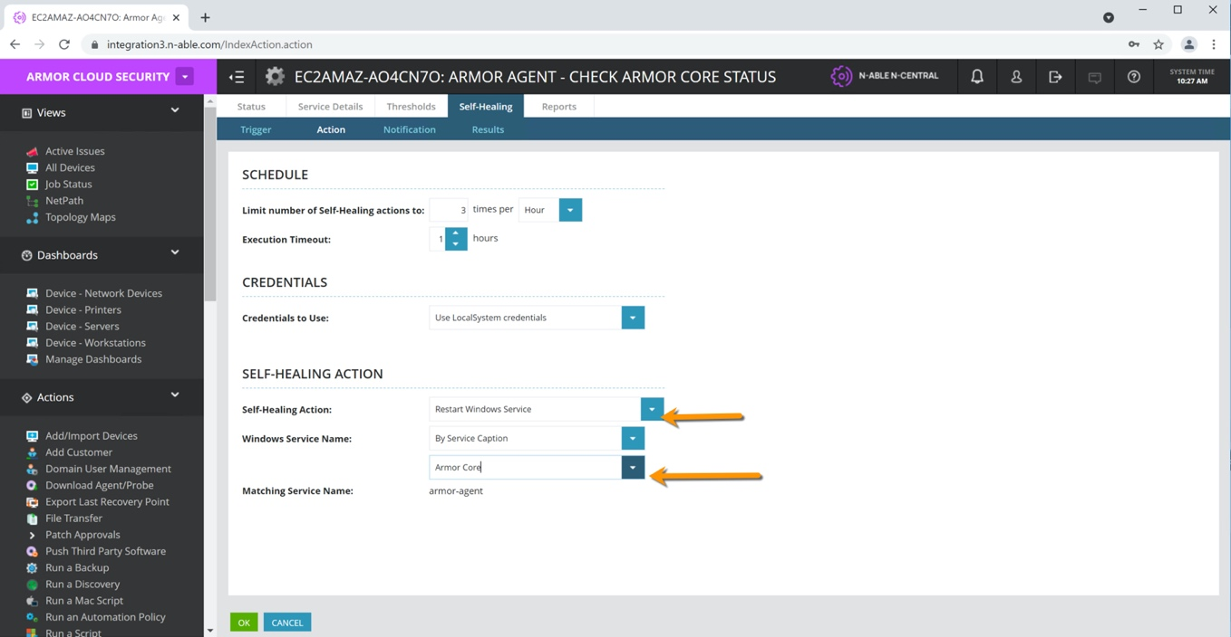

# Test the Self-Healing Policy

### Step 24 – Navigate to Views 🡪 All Devices 🡪 <machine name> 🡪 Monitoring tab

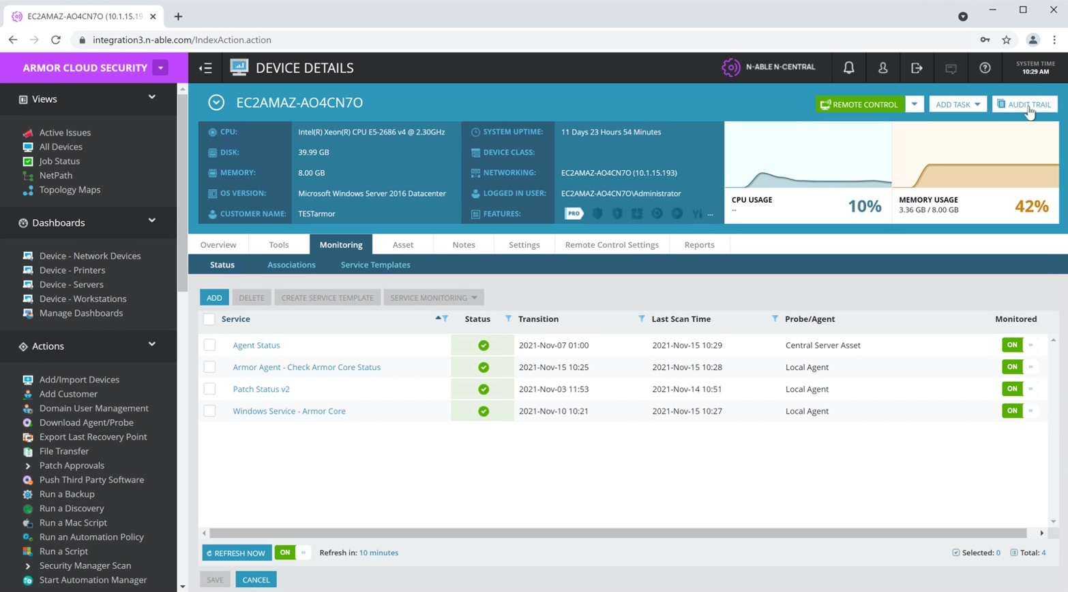

### Step 25 – Go into Windows 🡪 Computer Management 🡪 Services

Stop the Armor Core service.

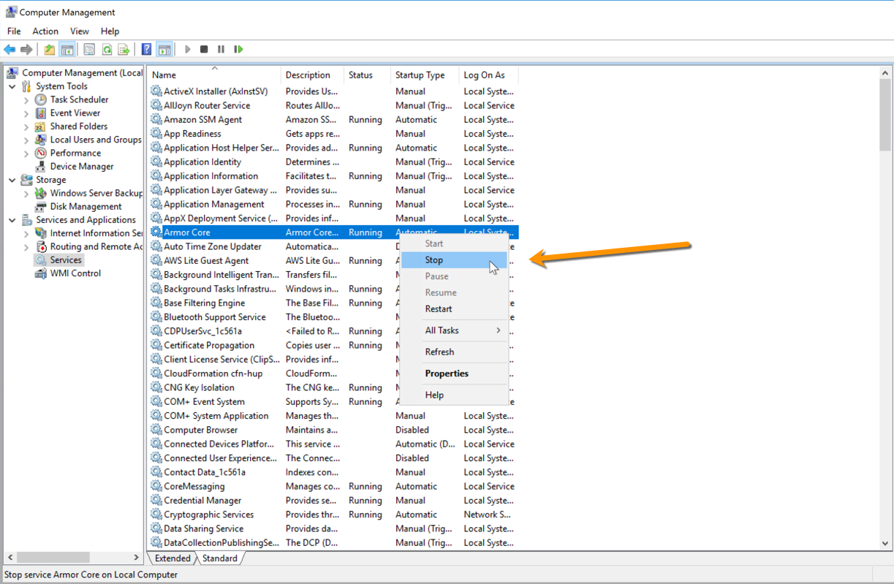

### Step 26 – In N-Central, from the customer view, Navigate to Reports 🡪 Events

Click on the Self-Healing card.

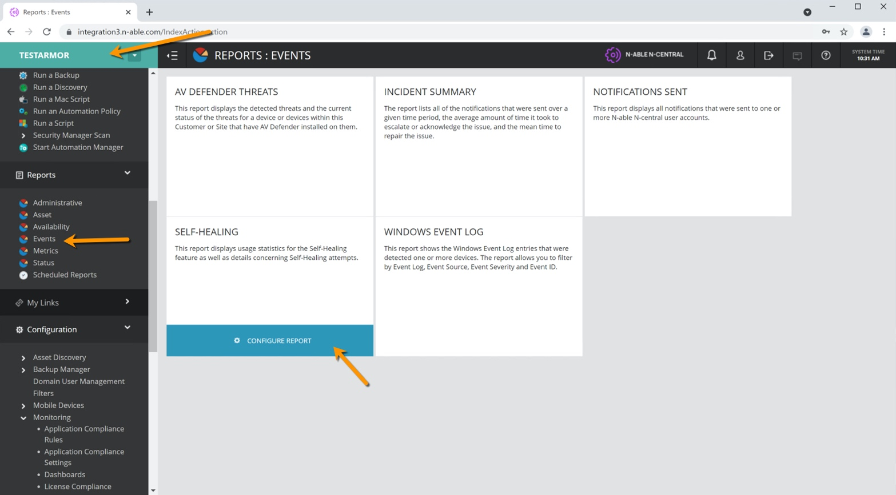

### Step 27 – View Report

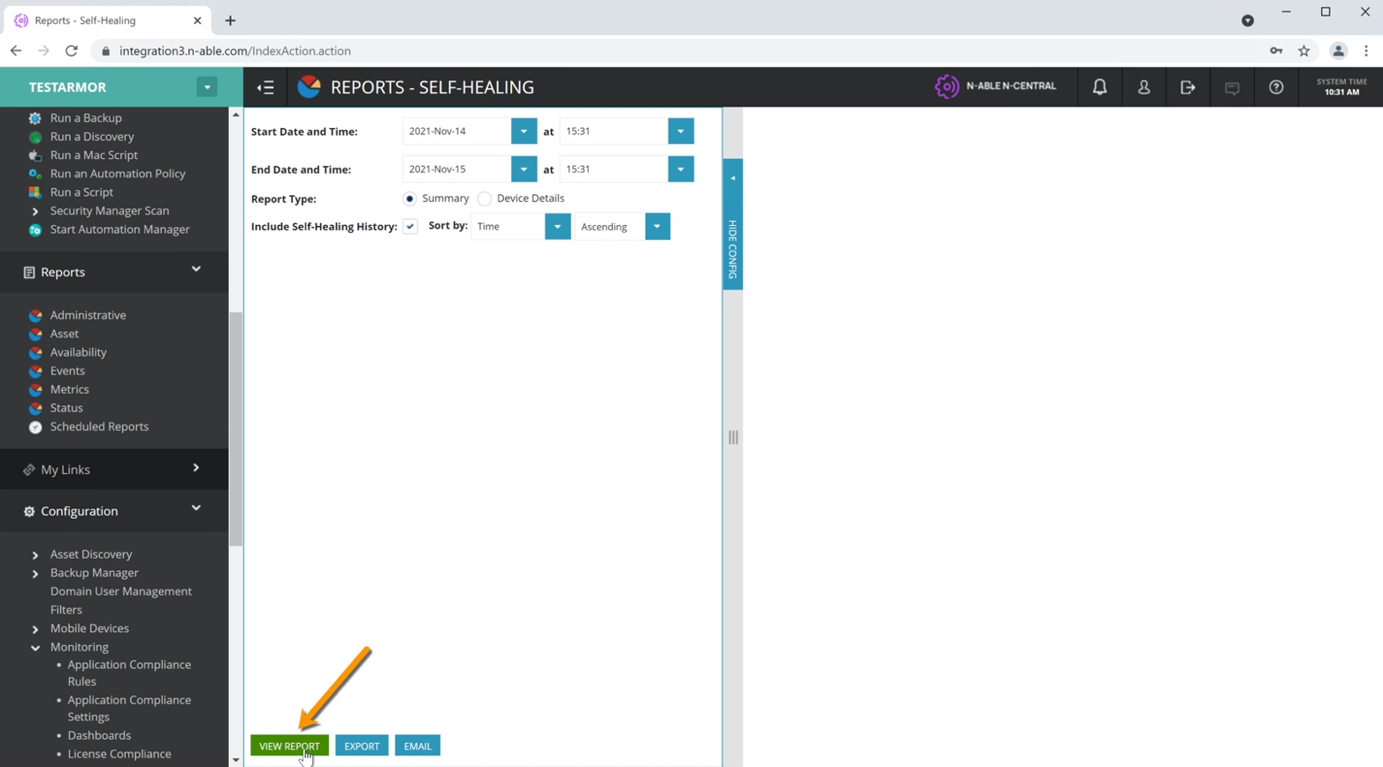

From here you can view the Self-Healing attempts.

